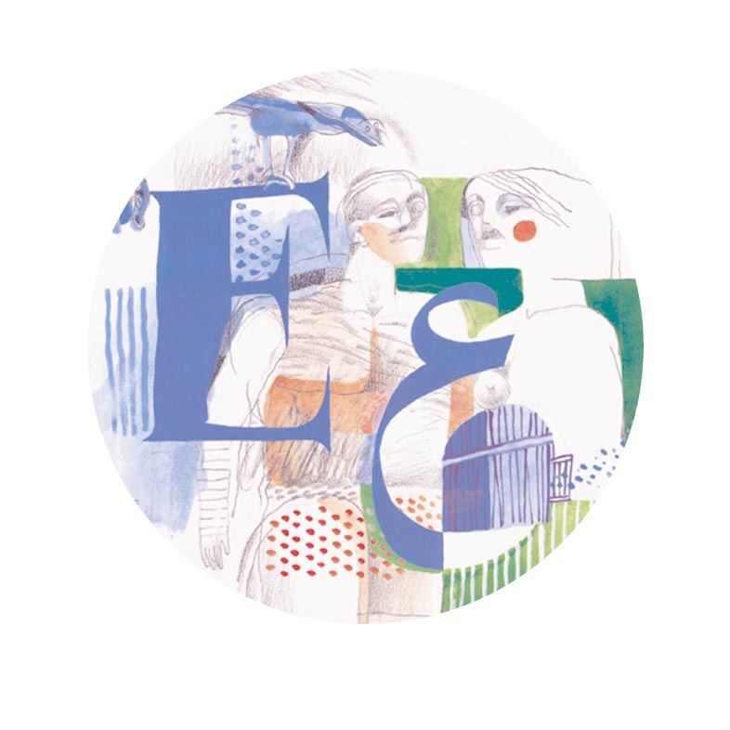

THE SAIF GHOBASH – BANIPAL
PRIZE FOR ARABIC
LITERARY TRANSLATION

In announcing the 2008 award for Arabic Literary Translation, the Trustees pay tribute to the author of the winning translation, Mahmoud Darwish, who tragically passed away on 9 August. The Prize is awarded to Fady Joudah for his translation of Mahmoud Darwish’s poetry in The Butterfly’s Burden, published in a bilingual edition by Bloodaxe Books in the UK, and by Copper Canyon Press in the USA. This year’s judges are literary translator Marilyn Booth, author Aamer Hussein and Bloomsbury commissioning editor Bill Swainson. Literary translator Roger Allen is chair of judges for the Banipal Trust. Mahmoud Darwish knew of the award, and personally congratulated Fady Joudah.

Speaking for the judges, Roger Allen states: “Following on from the precedents of the past two years of the translation prize competition, this year’s submissions were overwhelmingly in fictional form, and specifically novels. In spite of that however and the fact that the previous two winners of the prize had been translations of novels, it was the unanimous view of this year’s jury that the prize this year should be awarded to a bilingual anthology of poetry.

“Mahmoud Darwish is, needless to say, in no need of introduction as an author, in that he has long been acknowledged as one of the two or three most prominent poets in today’s Arab world, and internationally, and has been for over half a century the predominant poetic voice of the Palestinian people. While his poetry has already been translated and anthologised widely, this bilingual anthology, The Butterfly’s Burden, compiled and translated by Fady Joudah, brings together three more recent collections, [The Stranger’s Bed] (1998), the lengthy poem, [A State of Siege], and [Don’t Apologize for What You’ve Done] (2003). The translator’s sensitivity to the nuances and music of the original texts is already evident in the way in which the poetry is introduced and the translation process discussed in the Preface. Darwish is there described as ‘a songmaker whose vocabulary is accessible but whose mystery is not bashful.’ The resulting versions in English replicate, deliberately so, the structures of the original poems that parallel them on the opposite page, and yet they can be read in their English forms as wonderful transfers of the images and music of the Arabic poems. It goes without saying that this is a major achievement. Darwish’s recent contributions to contemporary Arabic poetry and to the literary tradition of his Palestinian people – most especially the siege poem emerging from the Second Intifada – are here made available in a carefully produced and beautifully translated volume.

“The runner-up is Ghassan Nasr’s translation of the late Jabra Ibrahim Jabra’s last novel, The Journals of Sarab Affan, published by Syracuse University Press. It is the work of another Palestinian author who was poet, novelist, art and music critic, and himself a superb translator of English literature and criticism into Arabic (not least the tragedies and sonnets of Shakespeare). Following a favourite pattern of this novelist, the work is narrated through the voices of two contrasting narrator-characters, one a prominent novelist and other a woman who falls in love with him. As is to be expected with the writings of this poet-novelist, the Arabic text is couched in language of exquisite beauty, and Ghassan Nasr succeeds admirably in transferring the nuances of the original to an English version that is a pleasure to read.’

“A third submission wins commendation – the translation by Nancy Roberts of Salwa Bakr’s The Man from Bashmour, published by The American University in Cairo Press. The jury was deeply impressed by Bakr’s courageous novelistic exploration of Egypt’s complex relationship with its Christian (Coptic) community during the 9th century AD. The Man from Bashmour is a historical novel that clearly involved its author in a large amount of research into the life of the community, the language of its liturgies, and the history of its status within the Muslim communities of Egypt. The text uses highly complex levels of discourse, and the translation project has therefore been a significant challenge, one that has been met with great success by the translator. This novel is an important contribution to the continuing tradition of historical fiction-writing in Arabic, especially within the Egyptian context, and its translation into English in such an accomplished fashion is to be welcomed.”

Commenting on the results, Marilyn Booth said that the high quality of submissions and the range of publishers represented in this year's Banipal Prize competition were evidence that contemporary Arabic literature was enjoying growing international interest and the attention of skilled translators. “Joudah’s brilliant translation and presentation of recent works by the renowned poet Mahmoud Darwish, she added, “allows the reader of English to savour the solid and carefully crafted building blocks of Darwish’s bold and delicate imagery and the echoes of his sound patterns. Darwish has long been an eloquent voice for Palestinian identity, aspirations, and rights, but his poetry is never reducible to politics, and this volume above all communicates Darwish’s mighty artistic presence at this utterly mature period of his poetic career.”

Marilyn Booth went on to say that the runner-up, Ghassan Nasr, in his translation of Jabra’s novel “captures beautifully the intense delicacy of human intimacy that this leading writer’s fiction traces”, while the commended translation by Nancy Roberts of Salwa Bakr’s historical novel, “itself a tour de force in its imaginative retracing of a turning point in Egypt’s history and one that carries great political sensitivity in contemporary circumstances, is a translation that conveys the double language of a historical moment and a contemporary resonance, with its careful use of archaisms and its respect for Bakr’s intensely historical, archival language.”

The jury expressly noted that “the quality of the majority of submissions to this year’s competition was extremely high, an indication of the ever-increasing skills exhibited by the still relatively small number of translators who are devoting themselves to the transfer of the treasures of the modern Arabic literary tradition to an English readership.”

Fady Joudah is a Palestinian American poet, a practising physician and poetry translator. He was born in Austin, Texas, and grew up in Libya and Saudia Arabia, returning to the US for college and medical training in internal medicine at the University of Texas Medical Center in Houston, where he lives and works today. His first poetry collection, The Earth in the Attic, received the 2008 Yale Series for Younger Poets award, judged by Louise Glück. The US edition of The Butterfly’s Burden by Copper Canyon Press was short-listed for PEN America’s poetry in translation award this year.

On hearing the news of the Saif Ghobash – Banipal Award, he said: “I am stunned with joy. I had no idea that I was up for the translation prize. Translating Darwish’s poetry was a dream of beauty, of art, with the glimmer that art will lead to cultural and mutual respect among peoples and in making the translations I focused as much on the strange in the poems as on the familiar and the universal.”

Monday 29 September

The Queen Elizabeth Hall, South Bank Centre, London SE1

6.30 pm

Readings by the translators from the prize-winning translations

8.00 pm

Presentation of the Translation Prizes
by Sir Peter Stothard, Editor, Times Literary Supplement

followed by

The 2008 Sebald Lecture on the Art of Literary Translation

Louis de Bernières

speaking on “A Day Out for Mehmet Erbil”

The Saif Ghobash – Banipal Prize is administered by the Society of Authors in the UK, together with a number of well-established United Kingdom prizes for literary translation into English from European languages, such as the prestigious Scott Moncrieff Prize for translation from French. The Award Ceremony is hosted by the British Centre for Literary Translation, the Arts Council, and the Society of Authors. The annual prize of £2,000 is awarded to the translator of a published translation in English of a full-length imaginative and creative Arabic work of literary merit published in the thirty-five years prior to submission of the translation and first published in English translation in the year prior to the award. Entries can have been published anywhere in the world but must be available for purchase in the United Kingdom, either via a distributor or on-line. The prize, the first specifically for a published work of English literary translation from Arabic, was established in 2005 by Banipal, the magazine of modern Arab literature in English translation, and the Banipal Trust for Arab Literature, and is now sponsored by Omar Saif Ghobash in memory of his father, the late Saif Ghobash, a man passionate about Arabic literature and other literatures of the world.

For more information or to make an interview with the winning translator,
please contact

The Banipal Trust for Arab Literature
P O Box 22300 LONDON W13 8ZQ
Tel: 00 44 (0)20 8569 9747 Email: info@banipaltrust.org.uk www.banipaltrust.org.uk

